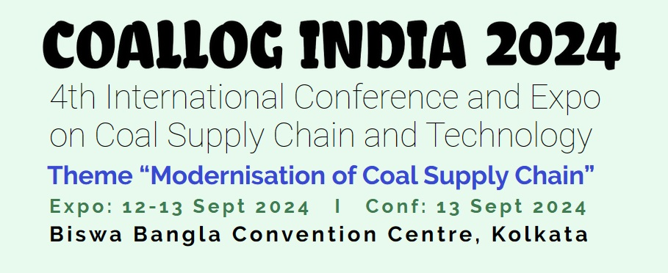 | Organised by  
Please complete and mail to:
BUSINESS MEDIA LINKS
#3, 3rd Floor, A 120, Lohia Nagar Ghaziabad ( UP) 201001
Tel: +91-9868332325, 9311253325
Email: : sk@coallogindia.com; coallogindia@gmail.com

DELEGATE REGISTRATION FORM

Organization
Address
City |  |  | Pin code
Contact No: |  |  | Email
GST No |  |  | PAN No
Address for GST
( If different from above)
 | Name | Designation |  | Mobile | Email
Delegate 1
Delegate 2
Delegate 3
Delegate 4

Conference Delegate Category (Please tick): Indian Overseas
CONFERENCE DELEGATE FEES (per delegate)
Registration Dates and Deadlines | Rate for Indian Participants | Rate for Overseas Participants | No of Delegates | Total Amount
01 May – 31 July 2024 | Rs. 10000 + 18% GST | USD 200 + 18% GST
01 Aug – 05 Sep 2024 | Rs. 12000 + 18% GST | USD 240 + 18% GST
06 Sep 2024 onwards  (Registration subjected to availability) | Rs. 14000 + 18% GST | USD 280 + 18% GST
Inclusions: Access to all sessions, Conference Lunch, Delegate Kit, AM-PM Tea/Coffee and refreshments, Evening Cocktail

Important Information:
• Standard Booking Deadline – 15 August 2024
Details for Bank Transfer:

Beneficiary Bank: ICICI Bank  Beneficiary Account Name: INDIAN COAL FORUM COAL LOG INDIA  Beneficiary Account No.: 054201002186 | Bank’s IFS Code: ICIC0000542  Bank Address: Basant Lok Branch - 49, Basant Lok, Vasant Vihar, New Delhi 110057  SWIFT Code: ICICINBBNRI

Terms and Conditions:

- Registration will be confirmed on realization of payment as per the applicable schedule of the Delegate fee.
- All payments made to COAL LOG INDIA are non-refundable
- Registration does not include any accommodation or transportation.
- Delegate badge is non-transferable. Delegates are requested to keep the delegate badge all through the event as access to the sessions, exhibition, lunch, are controlled by Delegate badges.
- No refunds on non – attendance, however, change in nomination can be done
- The Organizers shall be under no liability to the participant/s in respect to any actions, claims, losses including consequential losses, costs or expenses whatever, brought against or suffered or incurred by the delegate, in case of Emergency, Labour dispute, Strike, Lock down, Pandemic, Epedimic, Civil disturbance, Inevitable accident, Acts of God or any other cause not within the control of the Organizers.
- The Organizers reserves the right to make any amendments in the terms and conditions.
- Event will follow all advisories and guidelines of COVID 19 issued by the state / union government.

I / We have read the above Terms and Conditions of participation and shall abide by the same.

Date: ________________________________ Signature: __________________________________________________________

Place: ________________________________ Name & Designation: _________________________________________________________

Company Seal: _________________________________________________________

